Lab-8
Batch Code : ANP-D3393
Name : Vignesh S
ID : AF05054428
Topic : SQL

Database Schema: Consider a simple database with one tables: BankAccount BankAccount Table:
Columns: account_id (Primary Key), account_holder_name, account_balance
mysql> create database IOB_Bank;
Query OK, 1 row affected (0.01 sec)

mysql> use IOB_Bank;
Database changed
mysql> create table bank_account (account_id int primary key,account_holder_name varchar(100),
-> account_bal decimal (7,2));
Query OK, 0 rows affected (0.06 sec)
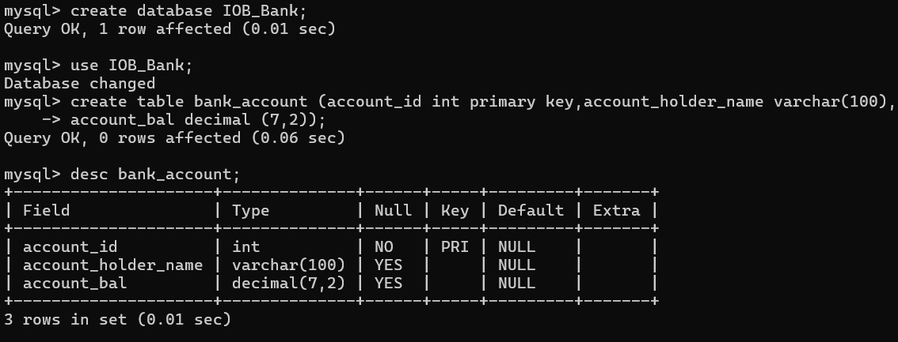

Insert Data
Write an SQL INSERT statement to insert data into the BankAccount table

mysql> insert into bank_account values(101,'vicky',32000),(102,'arjun',27000),
-> (103,'mukesh',31000),(104,'arun',26000),(105,'vishnu',30000);
Query OK, 5 rows affected (0.01 sec)
Records: 5 Duplicates: 0 Warnings: 0
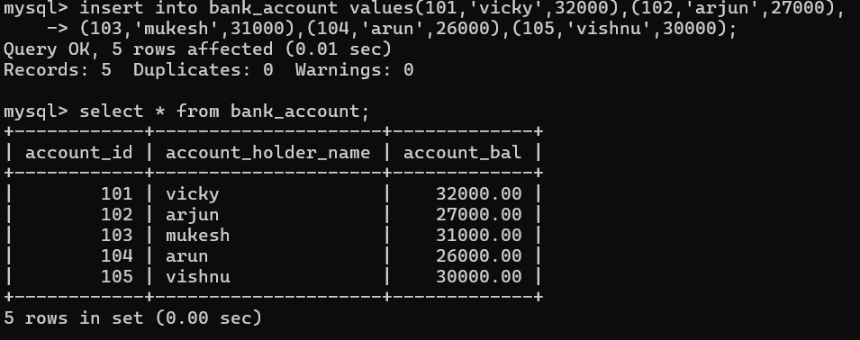

Retrieving Data
Write an SQL SELECT statement to retrieve the account_holder_name and account_balance of all account holders from the BankAccount table
mysql> select account_holder_name,account_bal from bank_account;
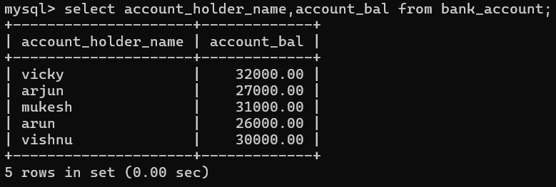

Filtering Data
Write an SQL SELECT statement to retrieve the account_holder_name and account_balance where the account_balance is more than 30,000
mysql> select account_holder_name,account_bal from bank_account where account_bal > 30000;
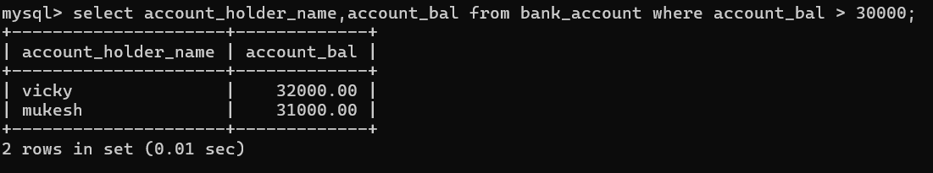

Updating Data
Write an SQL UPDATE statement to change the account_balance of the account holder whose ID is 101.
mysql> update bank_account set account_bal = 45000 where account_id = 101;
Query OK, 1 row affected (0.02 sec)
Rows matched: 1 Changed: 1 Warnings: 0
